16.20: a) 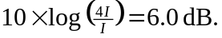 b) The number must be multiplied by four, for an increase of 12 kids.

